**Board implementation development**

1. **Current Report cube on Board**

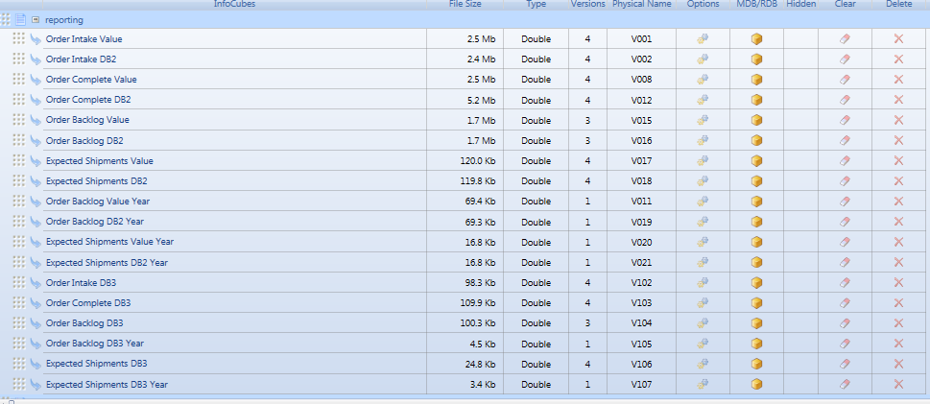

**The current cubes don’t distinguish between Pre-Calculation value and Post-calculation value.**

**E.g.:**

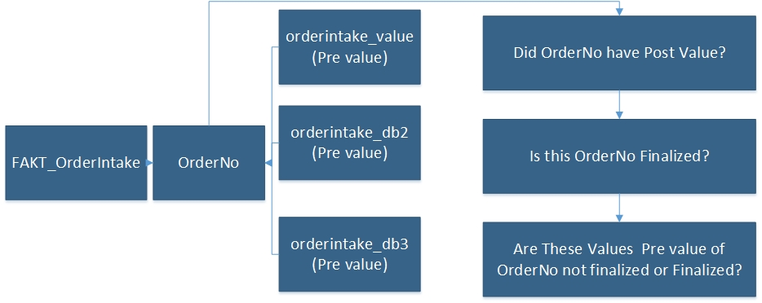

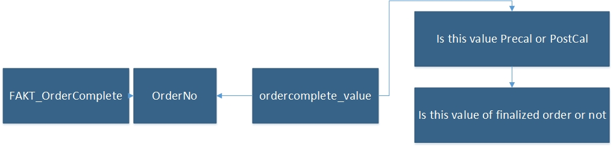

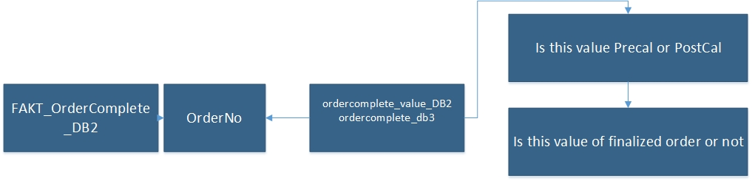

**Order Intake Value cube gets all value OrderValue (pre-cal) value for all orders**

**Order Intake DB2 cube gets all value OrderValue_DB2 (pre-cal) value for all orders**

**Order Complete Value cube gets value of ordercomplete_ value but no distinction Pre or Post ,depends on condition**

**Order Complete DB2 cube gets value of ordercomplete_ value but no distinction Pre or Post ,depends on condition**

**The same issue with other cubes**

**The current Cube data**

**Order Intake Value**

**Order Intake DB2**

**Order Intake DB3**

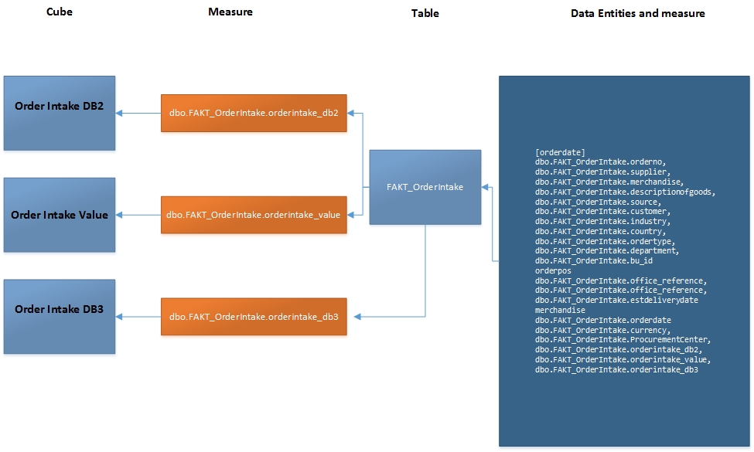

**Order Complete DB2**

**Order Complete DB3**

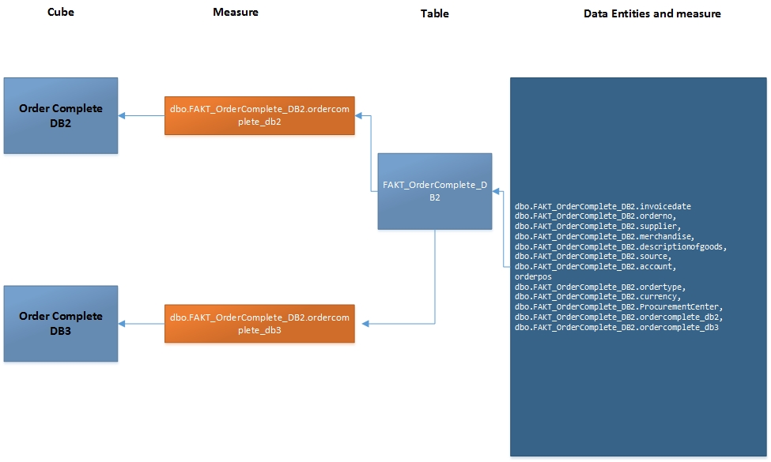

**Order Complete Value**

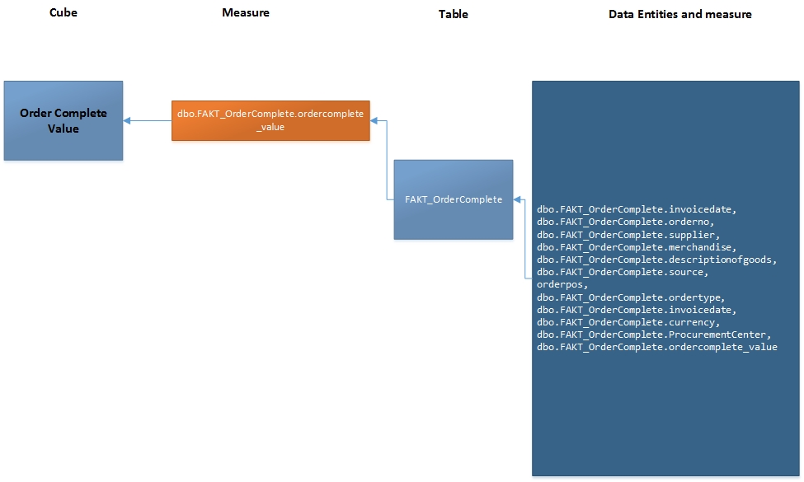

**Order Backlog Value**

**Order Backlog DB2**

**Order Backlog DB3**

**Order Backlog Value Year**

**Order Backlog DB2 Year**

**Order Backlog DB3 Year**

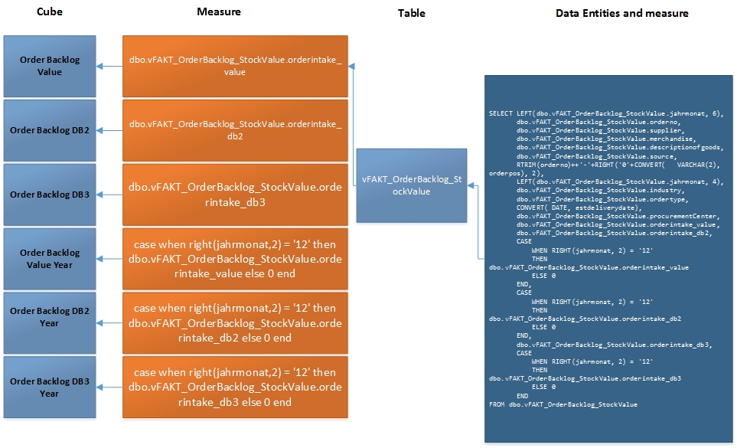

**Expected Shipments Value**

**Expected Shipments DB2**

**Expected Shipments DB3**

**Expected Shipments Value Year**

**Expected Shipments DB2 Year**

**Expected Shipments DB3 Year**

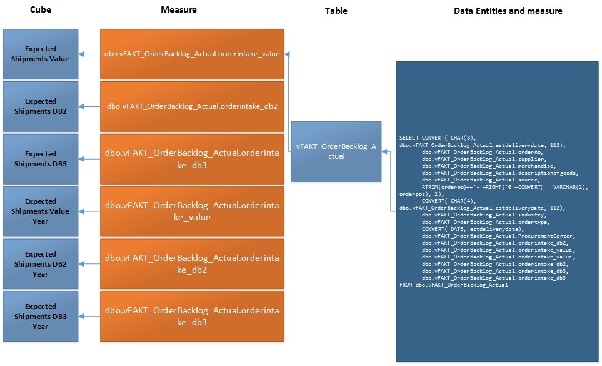

1. **Solution**

**So we implement two group reporting and name PreCal-Reporting and PostCal-Reporting**

**For per group contains 18 cubes and the name will suffix (Pre) or (Post) for each cube’s name like original cube below**



**Group Reporting –PreCal**

**Pre Order Intake Value**

**Pre Order Intake DB2**

**Pre Order Complete Value**

**Pre Order Complete DB2**

**Pre Order Backlog Value**

**Pre Order Backlog DB2**

**Pre Expected Shipments Value**

**Pre Expected Shipments DB2**

**Pre Order Backlog Value Year**

**Pre Order Backlog DB2**

**Pre Expected Shipments Value Year**

**Pre Expected Shipments DB2 Year**

**Pre Order Intake DB3**

**Pre Order Complete DB3**

**Pre Order Backlog DB3**

**Pre Order Backlog DB3 Year**

**Pre Expected Shipments DB3 Year**

**Group Reporting – Post if yes, else Pre**

**Order Intake Value v2**

**Order Intake DB2 v2**

**Order Complete Value v2**

**Order Complete DB2 v2**

**Order Backlog Value v2**

**Order Backlog DB2 v2**

**Expected Shipments Value v2**

**Expected Shipments DB2 v2**

**Order Backlog Value Year v2**

**Order Backlog DB2 v2**

**Expected Shipments Value Year v2**

**Expected Shipments DB2 Year v2**

**Order Intake DB3 v2**

**Order Complete DB3 v2**

**Order Backlog DB3 v2**

**Order Backlog DB3 Year v2**

**Expected Shipments DB3 v2**

**Expected Shipments DB3 Year v2**

**Create two groups Data Reader to get data DWH**

**Group 1: Fact Pre logic :**

**order intake: get more** Precal_IntakeValue, Precal_IntakeValue_currency, Precal_IntakeDB2, Precal_IntakeDB2_currency, Precal_IntakeDB3 **where Calculation_status=0**

**order complete DB2: get more** Precal_Value_DB2 and  **where Calculation_status=0**

**order complete value: get more** Precal_Value,Precal_currency and  **where Calculation_status=0**

**order backlog stock:**

**order backlog actual**

**Group 2: Fact v2 Logic**

**order intake: : get more** Postcal_IntakeValue, Postcal_IntakeValue_currency, Postcal_IntakeDB2, postcal_IntakeDB2_currency, Postcal_IntakeDB3 and if is null, get Precal_IntakeValue, Precal_IntakeValue_currency, Precal_IntakeDB2, Precal_IntakeDB2_currency, Precal_IntakeDB3 and **where Calculation_status=1**

**order complete DB2**

**get more** Postcal_Value_DB2 and If Postcal_Value_DB2 is null, get Precal_Value_DB2 and  **where Calculation_status=1**

**order complete value**

**get more** PostCal_value, PostCal_value_currency and if PostCal_value, PostCal_value_currency is null,get Precal_Value,Precal_currency **and where Calculation_status=1**

**order backlog stock**

**order backlog actual**

All cubes will get data from Data Warehouse by data reader on Board Application .

At DWH layer : some tables will be changed structure. Detail,

**FAKT_Ordercomplete** will add 5 columns ( Precal_Value,Precal_currency, PostCal_value, PostCal_value_currency, calculation_status)

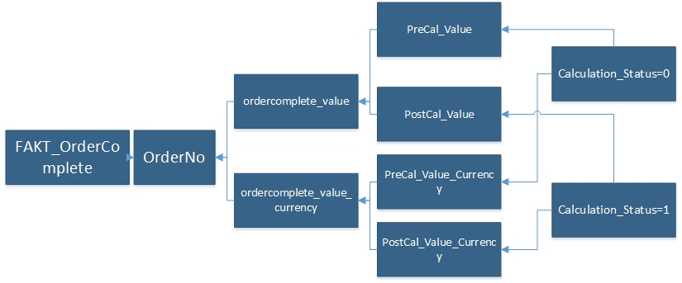

**FAKT_Ordercomplete_DB2** will add 5 columns ( Precal_Value_DB2,Precal_ Value_DB3, Postcal_Value_DB2,Postcal_ Value_DB3, calculation_status)

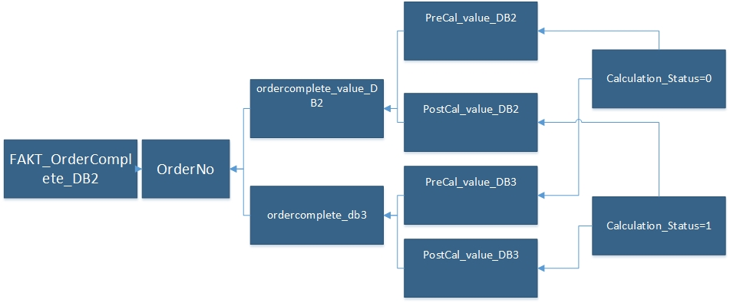

**FAKT_OrderIntake** will add 11 columns

(Precal_IntakeValue, Precal_IntakeValue_currency, Postcal_IntakeValue, Postcal_IntakeValue_currency,

Precal_IntakeDB2, Precal_IntakeDB2_currency, Postcal_IntakeDB2, Postcal_IntakeDB2_currency,

Precal_IntakeDB3, Postcal_IntakeDB3,calculation status)

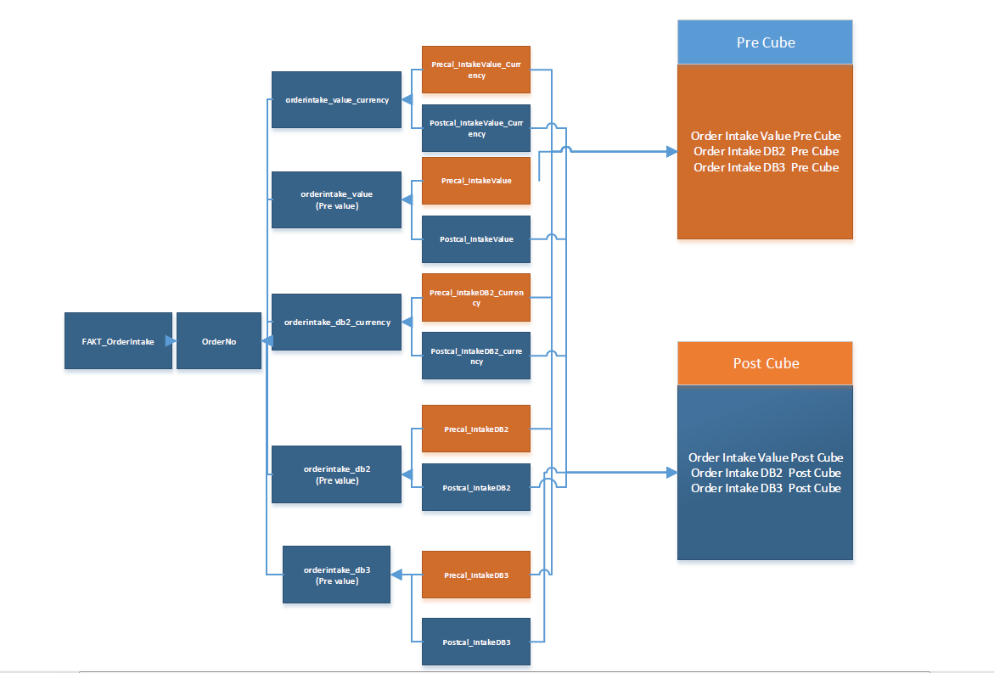

**vFAKT_OrderBacklog_Actual** will add 11 columns

(Precal_IntakeValue, Precal_IntakeValue_currency, Postcal_IntakeValue, Postcal_IntakeValue_currency,

Precal_IntakeDB2, Precal_IntakeDB2_currency, Postcal_IntakeDB2, Postcal_IntakeDB2_currency,

Precal_IntakeDB3, Postcal_IntakeDB3,calculation_status)

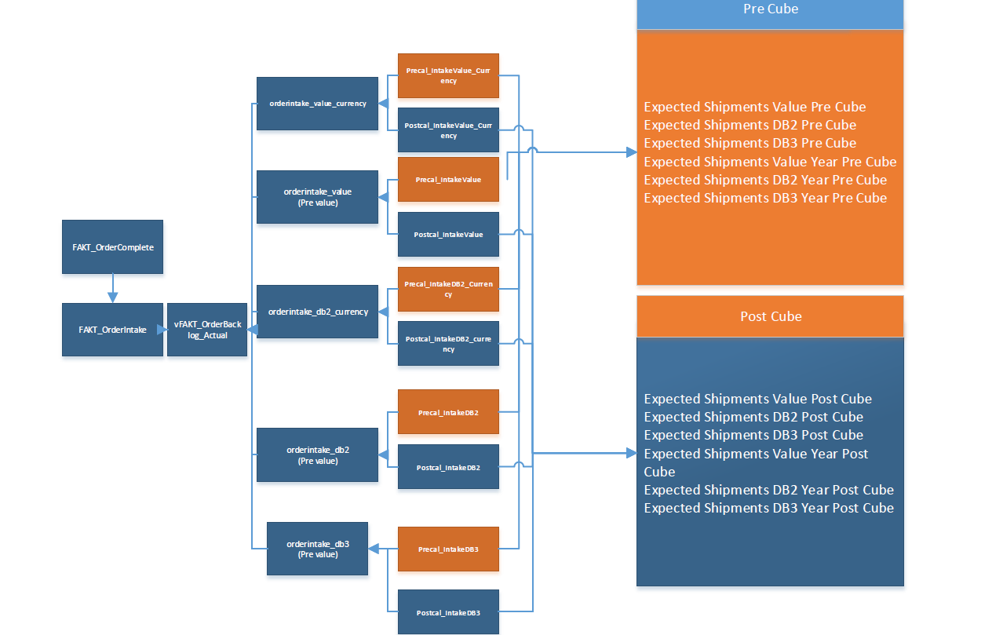

**vFAKT_OrderBacklog_StockValue** will add 11 columns

(Precal_IntakeValue, Precal_IntakeValue_currency, Postcal_IntakeValue, Postcal_IntakeValue_currency,

Precal_IntakeDB2, Precal_IntakeDB2_currency, Postcal_IntakeDB2, Postcal_IntakeDB2_currency,

Precal_IntakeDB3, Postcal_IntakeDB3,calculation status)

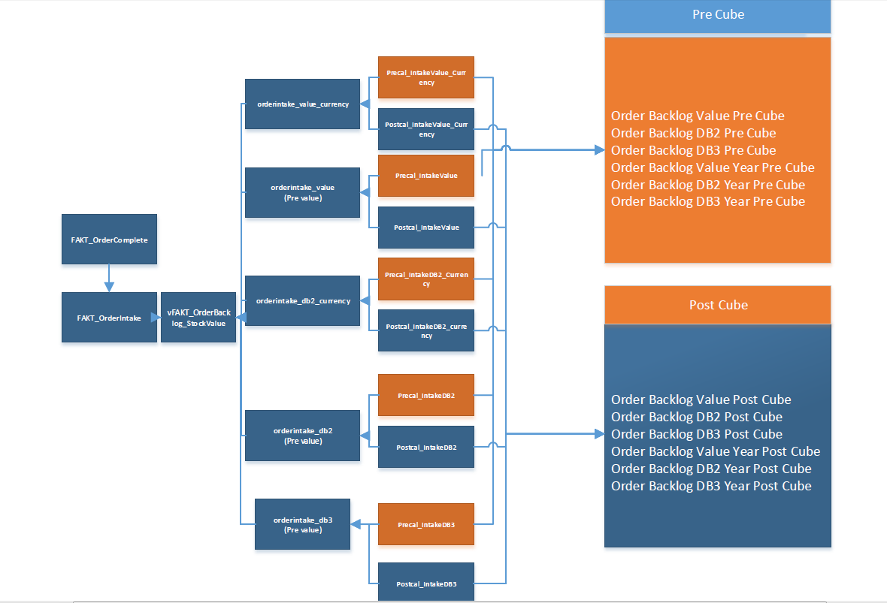

**We determine that when [calculation_status] equal 1, is Post-Calculation value else equal 0 , is Pre-Calculation. We will load data wil have value of [calculation_status] equal 1 for group cubes (Post) and value of [calculation_status] equal 0 for (Pre)**